**Luke Jacobe D. Magboo BSIT ll**

**NETWORKING 1 – WEEK 5 – ACTIVITY 1**

Supply/perform what is asking in the following statements. Create and attach a screenshot for each number to support your answer. Put your screenshot(s) inside your word document to make all the screenshots be uploaded in the STCFlip.

1. Find the MAC addresses of your network adapters (LAN and WIFI) and briefly explain the steps or methods you used or performed to get the addresses. (Provide at least 3 methods)

Step 1: In the task bar search View network connection

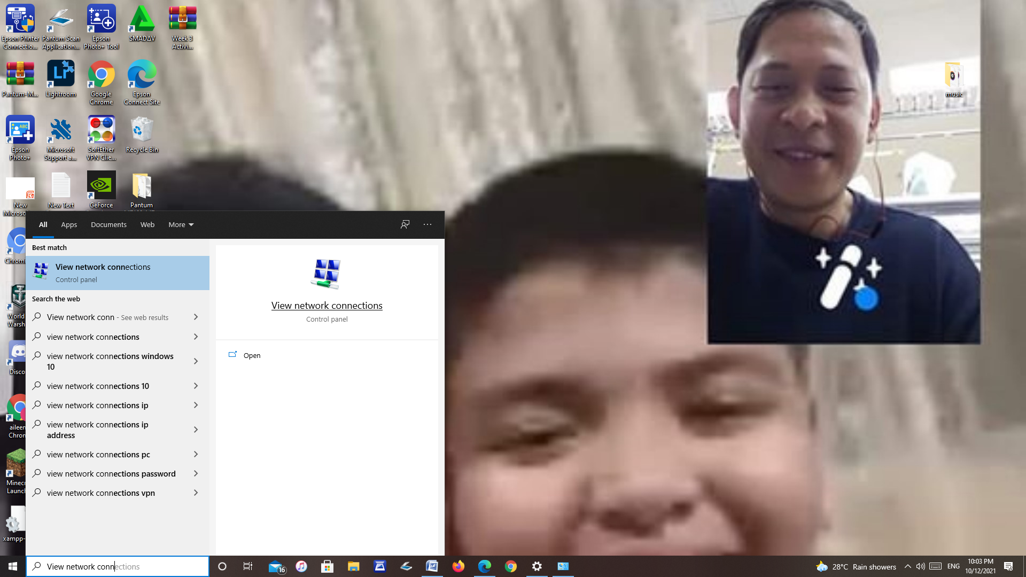

Step 2: Right click your Ethernet connection and then click status

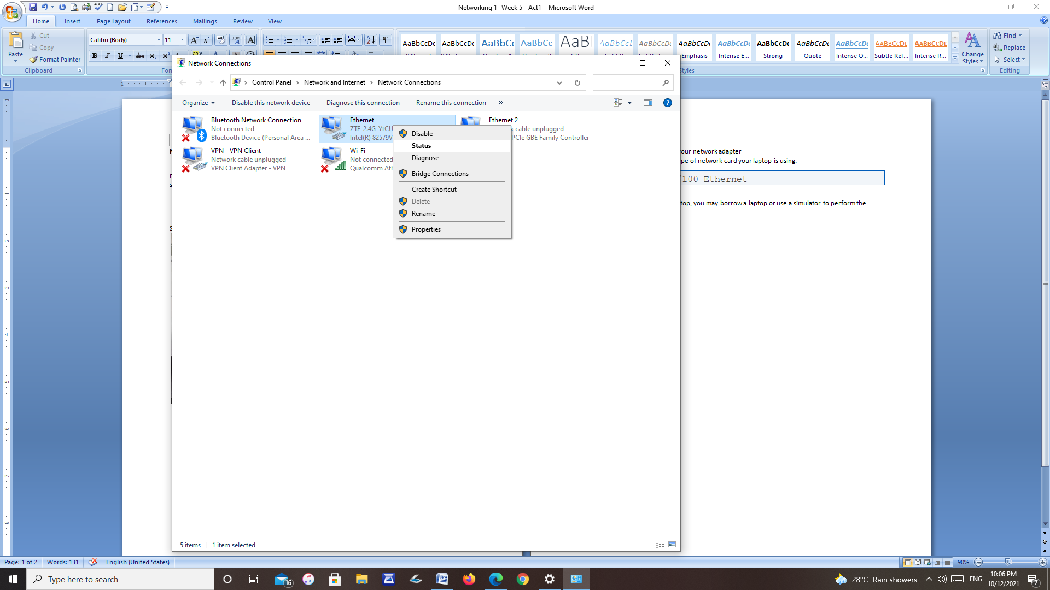

Step 3: After that you see the MAC address or the Physical Address

This is the MAC address of my network **C8-60-00-CC-8D-AD**

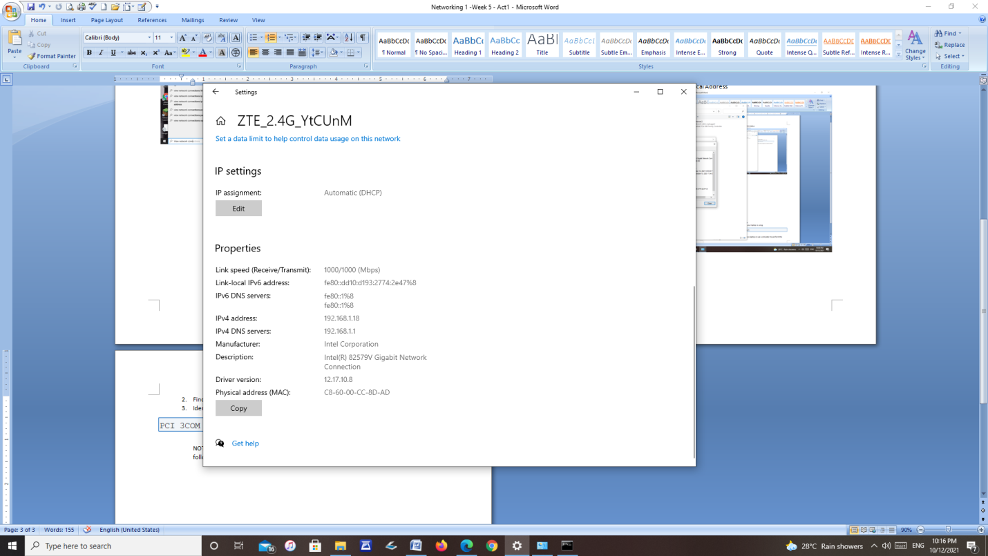

1. Find the IP address of your network adapter

The IP Address of my network is **192.168.1.18**

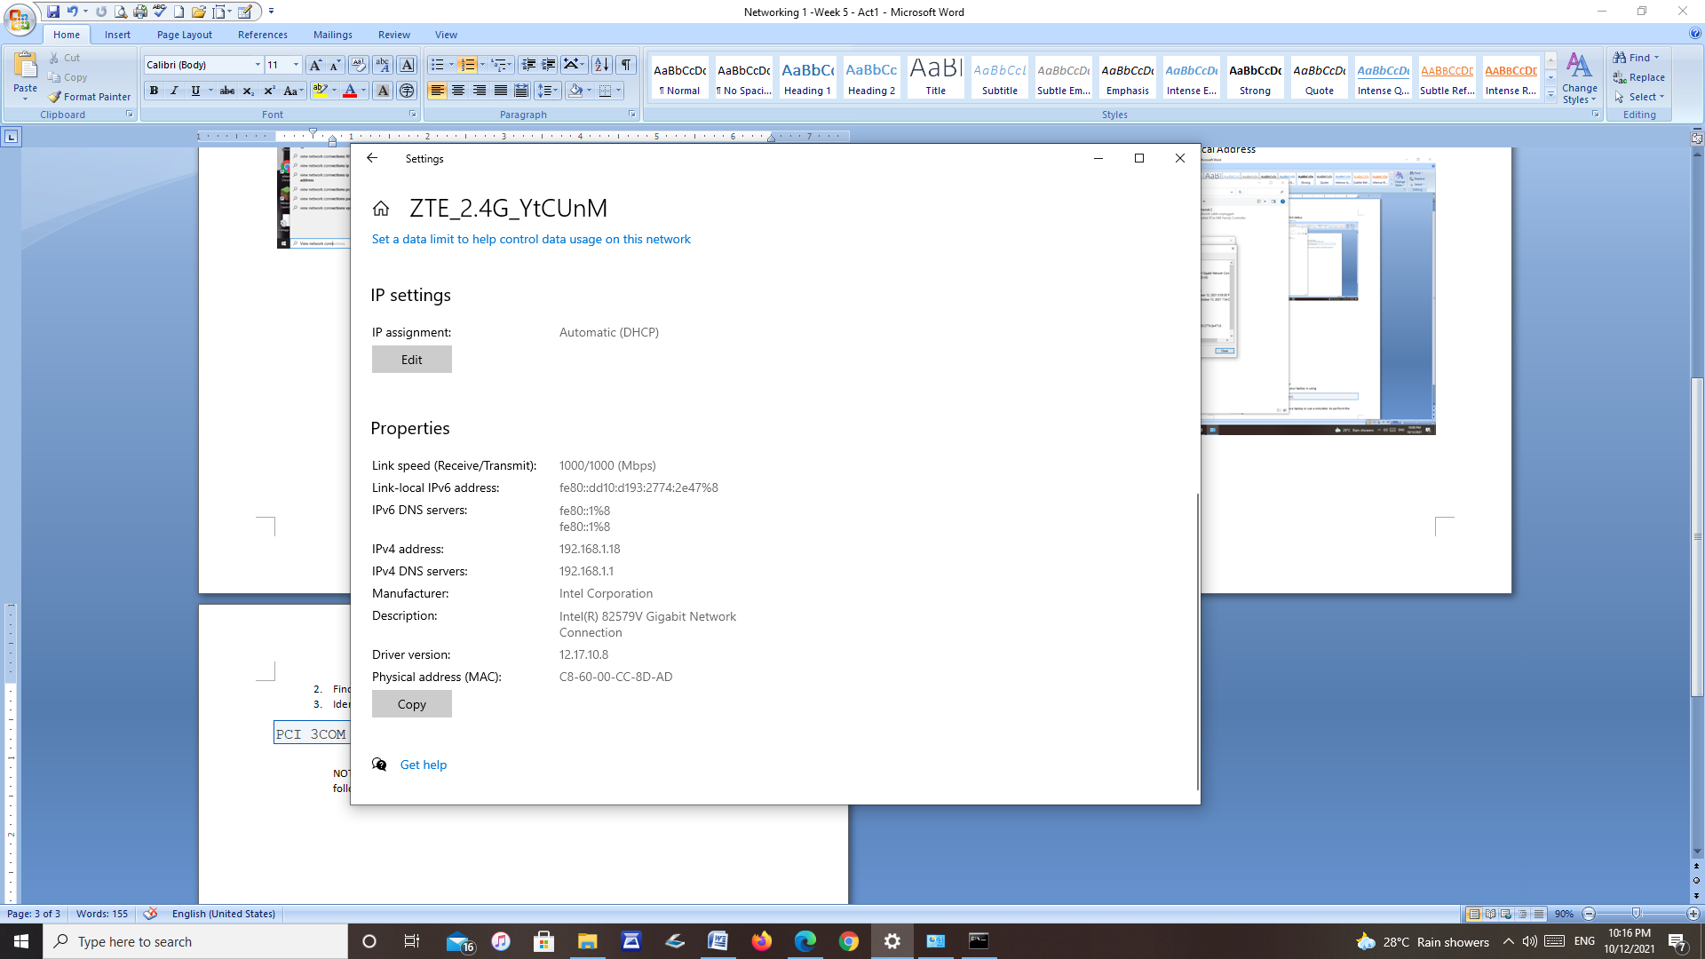

1. Identify what kind or type of network card your laptop is using.

The type of network of my laptop is Ethernet

PCI 3COM 3C905B 10/100 Ethernet

NOTE: If there is no laptop, you may borrow a laptop or use a simulator to perform the following.